On Tables and Graphs

Kristine Dinh & Yan Ke

10/01/2020

1. A misleading graph comes from the newspaper (thesun.co.uk)

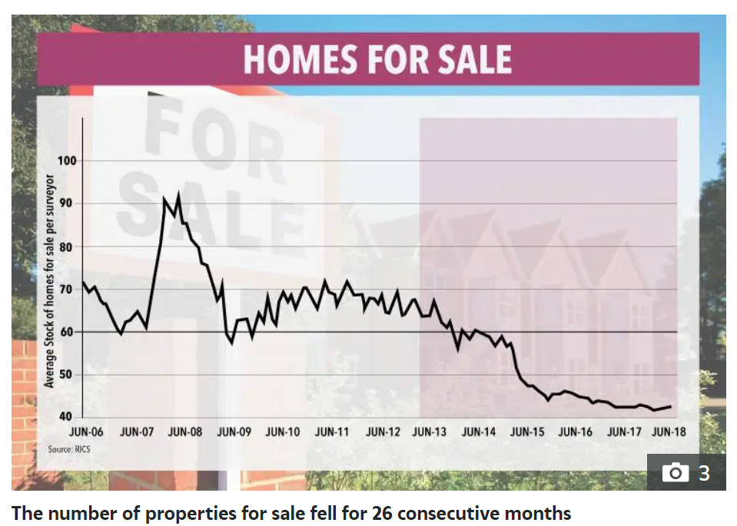

Every buyer wants to own a beautiful house with an ideal price. It is a really bad news for buyers as the house stock goes lower and the price goes higher. The graph above may be presented purposely to show the decreasing house stock in market in Halifax. Based on the trend of the graph, it is a misleading graph.

Firstly, the caption states that “The number of properties for sale fell for 26 consecutive months”. However, we only see parts of the graph. It does show us the decreasing trend. But what is the whole trend by considering all the data? In addition, the x-axis text is abundant. The author could have removed “JUN-” in all the points and add it on the caption instead. For example, the caption can be “The number of properties for sale fell for 26 consecutive months in June”.

Secondly, y-axis was expanded and started from 40 to show a greater decreasing over time. Ignore a slightly rise on JUN-08, the number of house changes from 70 to 40. However, it does not change a lot compare to the size of the city.

Last but not least, the design of the plot without legend would make the readers confused. For example, when we see the plot, we would ask these questions: What does the pink shaded area represent? Why is the line bolded where average stock of homes for sale is 60? What is the unit for the average stock of homes for sale?

2. A poorly presented table from the Mid Florida newspaper

Table 1: The total cases of COVID-19 by the County in Florida as of 11 a.m. June 14, 2020

Our life is being affected seriously by the COVID-19 pandemic this year. The news we care about most every day is the latest development of COVID-19 this year. Facing with lots of news related to COVID-19 floods in every day. How to present graphs and tables more effectively?

Table 1. comes from the Mid Florida Newspapers. It is a very simple table which shows us the total cases of COVID-19 by the county in Florida as of 11 a.m. June 14,2020. Based on the table, we only know the total cases by county which is ordered by alphabet. However, that is not we care about most. We want to figure out more information. For example, what is the total cases in Florida? Which county has the most cases? What is the rate of illness per County? It is hard to figure out that information easily. So, the table was poorly presented.

Two rules were violated in the table. The first one is: ‘All’ is different and is important. Picking the most relevant information to present would explain the point being made in the report much better. So, we add the total cases in Florida in the last row of the table and the rates per million in the last column of the table. The second one is: Order the rows in a way that makes sense. To make the table more effective, the authors should order the table in order related to the argument. For example, if the question asked was: What county has the most cases? Then the author would have to order the number of cases in descending order. Therefore, we cleaned the table as the following (there are 67 counties in Florida, so we choose those counties which have the 5 most and 5 least cases as example), see Table 2.

Table 2: COVID-19 rate of the top and bottom 5 counties

|  |  |  |  |
| --- | --- | --- | --- |
| **County** | **Total Resident Population**  **(in millions)** | **Total Cases** | **Rates Per Million** |
| Miami-Dade | 2.72 | 21,917 | 8,058 |
| Broward | 1.95 | 8,928 | 4,578 |
| Palm Beach | 1.52 | 8,833 | 5,811 |
| Hillsborough | 1.47 | 3,613 | 2,458 |
| Orange | 1.39 | 3,130 | 2,252 |
| ...... | ...... | ...... | ...... |
| Jefferson | 0.01 | 32 | 3,200 |
| Holmes | 0.02 | 31 | 1,550 |
| Gilchrist | 0.02 | 26 | 1,300 |
| Lafayette | 0.01 | 13 | 1,300 |
| Gulf | 0.02 | 8 | 400 |
| **Florida** | 21.48 | 75,568 | 3,518 |